- Purpose

  - To outline steps necessary to change out mix pot blades on the Primary Digesters (Asset Tag #10131 for the Liquid Side and #10154 for the Salt Side) on both the Salt and Liquid side of the Digester Room. This is a preventive maintenance procedure where the blades will be changed out every two (2) months.

- Scope

- Responsibility

- Safety Considerations

  - All safety glasses and appropriate safety apparel is to be worn at all times. This includes wearing the appropriate protection for working at heights above six feet. Safety is a condition of employment. Employees are not authorized to work in an unsafe manner and are prohibited from harming the environment of the facility or community.

- Materials/Equipment

- Procedure

This Preventive Maintenance and/or Repair procedure should be conducted only after the affected Primary Digester has been shut down (See Giles Procedure Starting and stopping digesters-Manufacturing Procedure Dig-05) The Lead Operator should be responsible for shutting down the Digester and notifying maintenance that the affected Digester and Mix Pot is available for repair/replacement.
- After confirming that Primary Digester that is being worked on is off, unplug power supply to Mix Pot motor and remove four bolts holding mix pot motor in place on the pot.
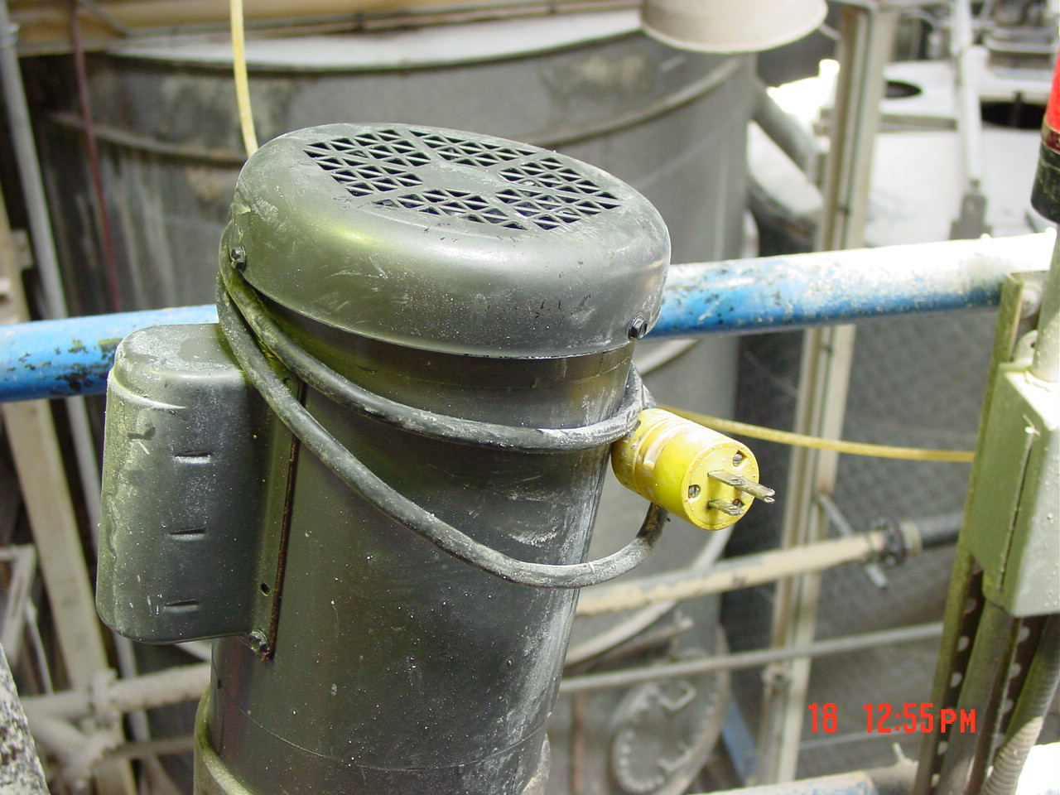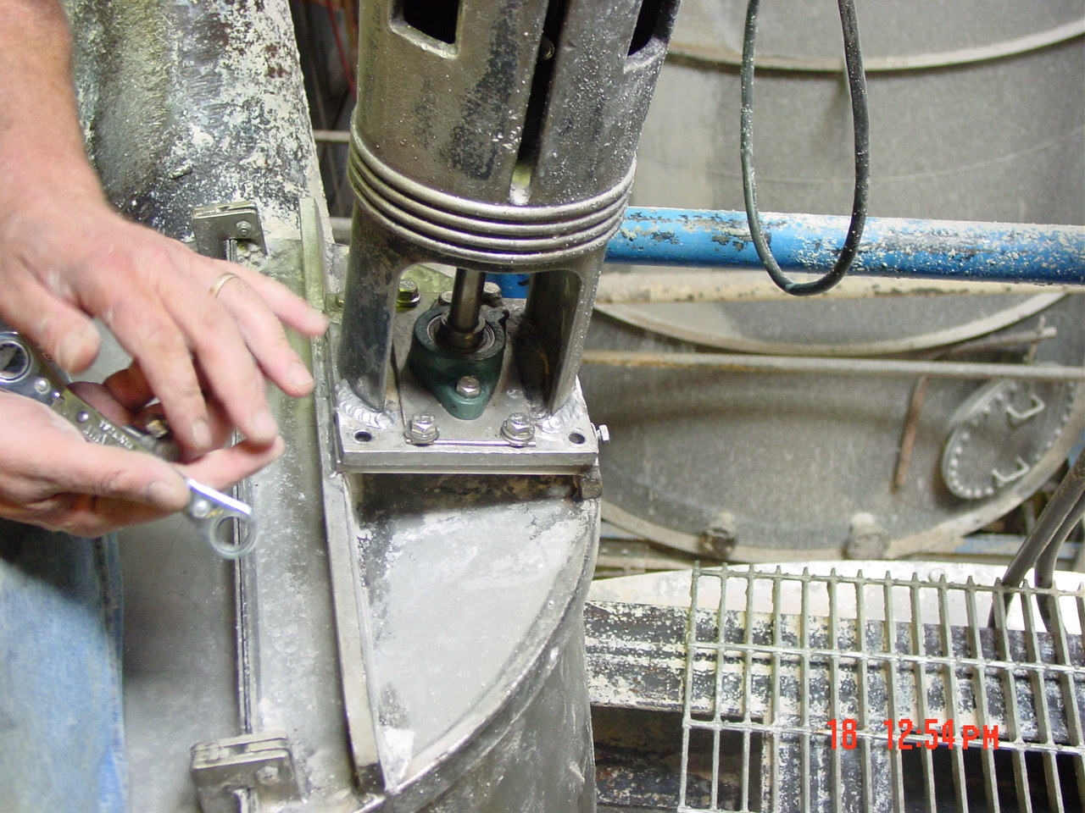

- After one mechanic lifts up motor and tilts back, another mechanic will loosen the old blades from the shaft and remove.
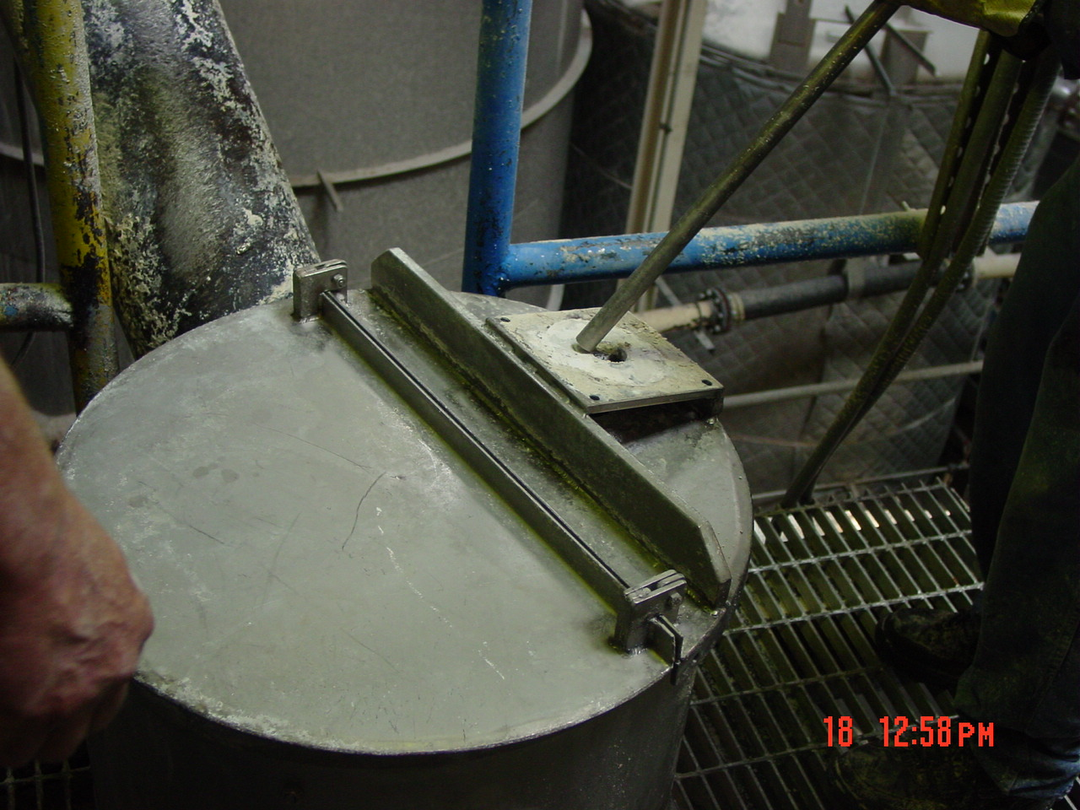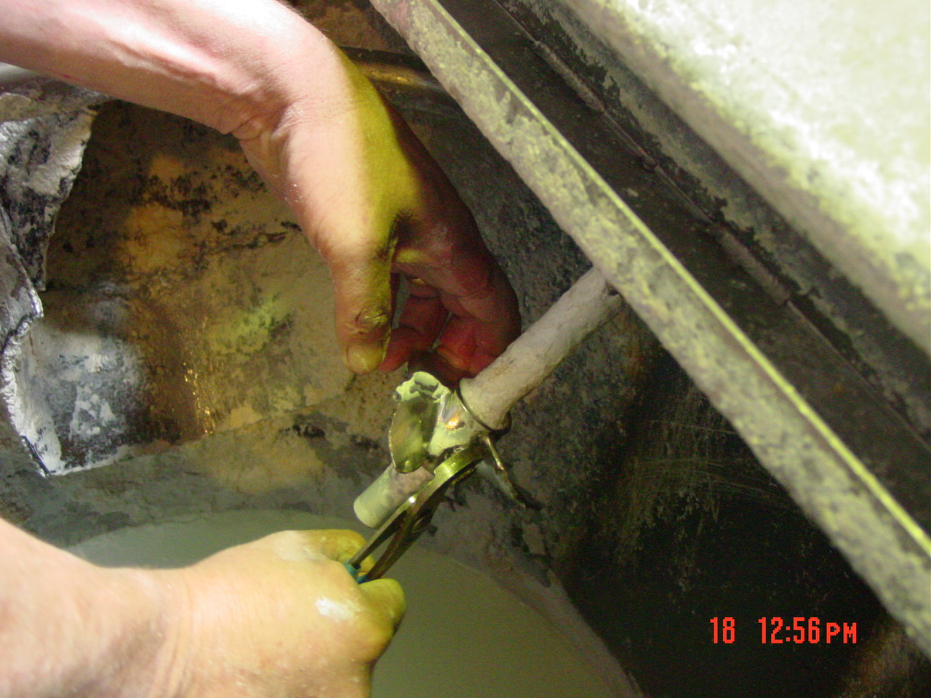
- Once old blades are removed, the new 6” blades should be installed
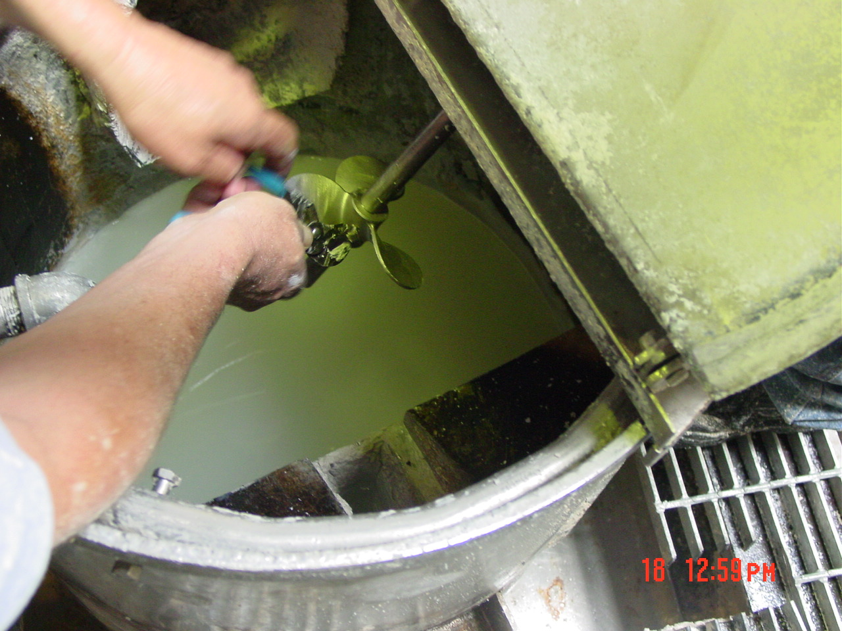
- After blade installation; carefully lower the motor back to the motor mount and re-install the four (4) bolts holding the motor in place.
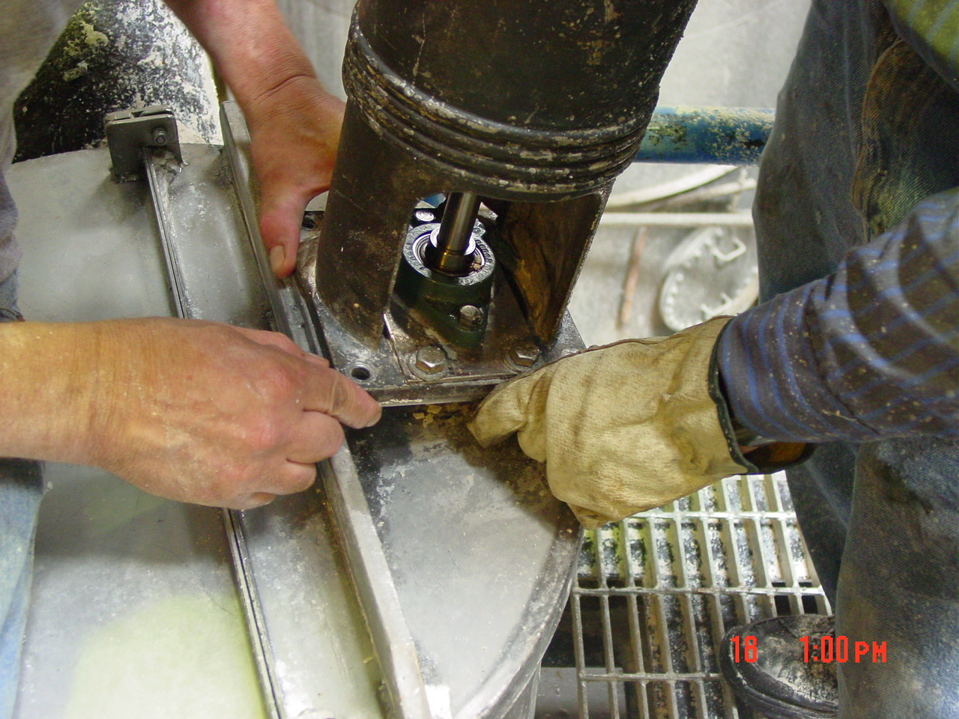
Then re-install electrical plug to proper location and place mix pot back into production. Notify Lead Operator that mix pot is available for production and to reverse procedure for shutdown of digesters.

- Reference Documents

- Amendment Record

Revision  Number | Revision  Date | Revision  Author | Revision Description
0 | 05/26/09 | RW/LP | New Document

